EcoTrack Project
Code:
#include <iostream>
#include <iomanip>
using namespace std;

/*=================================================
SINGLY LINKED LIST - WASTE RECORDS
=================================================*/
struct WasteNode
{
int id;
string date;
string type;
int quantity;
WasteNode *next;
};

WasteNode *wasteHead = NULL;
int wasteCounter = 1;

void addWasteRecord()
{
WasteNode *newNode = new WasteNode;

newNode->id = wasteCounter++;

cout << "\nEnter Date (DD-MM-YYYY): ";
cin >> newNode->date;

cout << "Enter Waste Type: ";
cin >> newNode->type;

cout << "Enter Quantity (Kg): ";
cin >> newNode->quantity;

newNode->next = NULL;

if (wasteHead == NULL)
{
wasteHead = newNode;
}
else
{
WasteNode *temp = wasteHead;

while (temp->next != NULL)
temp = temp->next;

temp->next = newNode;
}

cout << "Waste Record Added Successfully!\n";
}

void displayWasteRecords()
{
if (wasteHead == NULL)
{
cout << "\nNo Waste Records Available.\n";
return;
}

WasteNode *temp = wasteHead;

cout << "\n---------------------------------------------\n";
cout << left << setw(8) << "ID"
<< setw(15) << "Date"
<< setw(15) << "Type"
<< "Qty\n";
cout << "---------------------------------------------\n";

while (temp != NULL)
{
cout << left << setw(8) << temp->id
<< setw(15) << temp->date
<< setw(15) << temp->type
<< temp->quantity << endl;

temp = temp->next;
}
}

void deleteWasteRecord()
{
int id;

cout << "\nEnter Waste ID to Delete: ";
cin >> id;

WasteNode *temp = wasteHead;
WasteNode *prev = NULL;

while (temp != NULL && temp->id != id)
{
prev = temp;
temp = temp->next;
}

if (temp == NULL)
{
cout << "Record Not Found!\n";
return;
}

if (prev == NULL)
wasteHead = temp->next;
else
prev->next = temp->next;

delete temp;

cout << "Record Deleted Successfully!\n";
}

int getTotalWaste()
{
int total = 0;

WasteNode *temp = wasteHead;

while (temp != NULL)
{
total += temp->quantity;
temp = temp->next;
}

return total;
}

/*=================================================
DOUBLY LINKED LIST - RECYCLING HISTORY
=================================================*/
struct RecyclingNode
{
int wasteID;
string stage;
string status;

RecyclingNode *prev;
RecyclingNode *next;
};

RecyclingNode *recycleHead = NULL;
RecyclingNode *recycleTail = NULL;

void addRecyclingHistory()
{
RecyclingNode *newNode = new RecyclingNode;

cout << "\nWaste ID: ";
cin >> newNode->wasteID;

cout << "Processing Stage: ";
cin >> newNode->stage;

cout << "Status: ";
cin >> newNode->status;

newNode->next = NULL;
newNode->prev = recycleTail;

if (recycleHead == NULL)
{
recycleHead = recycleTail = newNode;
}
else
{
recycleTail->next = newNode;
recycleTail = newNode;
}

cout << "Recycling History Added!\n";
}

void displayRecyclingForward()
{
RecyclingNode *temp = recycleHead;

cout << "\n--- Recycling History (Forward) ---\n";

while (temp != NULL)
{
cout << "Waste ID: " << temp->wasteID
<< " | Stage: " << temp->stage
<< " | Status: " << temp->status << endl;

temp = temp->next;
}
}

void displayRecyclingBackward()
{
RecyclingNode *temp = recycleTail;

cout << "\n--- Recycling History (Backward) ---\n";

while (temp != NULL)
{
cout << "Waste ID: " << temp->wasteID
<< " | Stage: " << temp->stage
<< " | Status: " << temp->status << endl;

temp = temp->prev;
}
}

/*=================================================
CIRCULAR LINKED LIST - ROUTES
=================================================*/
struct RouteNode
{
string location;
int distance;
RouteNode *next;
};

RouteNode *routeHead = NULL;

void addRoute()
{
RouteNode *newNode = new RouteNode;

cout << "\nLocation Name: ";
cin >> newNode->location;

cout << "Distance (Km): ";
cin >> newNode->distance;

if (routeHead == NULL)
{
routeHead = newNode;
newNode->next = routeHead;
}
else
{
RouteNode *temp = routeHead;

while (temp->next != routeHead)
temp = temp->next;

temp->next = newNode;
newNode->next = routeHead;
}

cout << "Route Added!\n";
}

void displayRoutes()
{
if (routeHead == NULL)
{
cout << "\nNo Routes Available.\n";
return;
}

RouteNode *temp = routeHead;

cout << "\n--- Collection Routes ---\n";

do
{
cout << temp->location
<< " (" << temp->distance << " Km)\n";

temp = temp->next;

} while (temp != routeHead);
}

/*=================================================
HEADER LINKED LIST - SUMMARY
=================================================*/
struct CategoryNode
{
string category;
int quantity;
CategoryNode *next;
};

struct HeaderNode
{
int totalWaste;
int totalRecycled;
CategoryNode *next;
};

HeaderNode summary = {0, 0, NULL};

void addCategorySummary()
{
CategoryNode *newNode = new CategoryNode;

cout << "\nCategory Name: ";
cin >> newNode->category;

cout << "Quantity: ";
cin >> newNode->quantity;

newNode->next = summary.next;
summary.next = newNode;
}

void displaySummary()
{
summary.totalWaste = getTotalWaste();

cout << "\n========== RESOURCE SUMMARY ==========\n";
cout << "Total Waste Collected : "
<< summary.totalWaste << " Kg\n";

cout << "Total Recycled Waste : "
<< summary.totalRecycled << " Kg\n";

CategoryNode *temp = summary.next;

cout << "\nCategory Breakdown:\n";

while (temp != NULL)
{
cout << temp->category
<< " -> "
<< temp->quantity
<< " Kg\n";

temp = temp->next;
}
}

/*=================================================
MULTI LEVEL LINKED LIST
=================================================*/
struct WasteTypeNode
{
string wasteType;
WasteTypeNode *down;
};

struct LocationNode
{
string locationName;
WasteTypeNode *types;
LocationNode *next;
};

LocationNode *locationHead = NULL;

void addLocationWaste()
{
LocationNode *loc = new LocationNode;

cout << "\nLocation Name: ";
cin >> loc->locationName;

loc->types = NULL;
loc->next = locationHead;
locationHead = loc;

int n;

cout << "Number of Waste Types: ";
cin >> n;

WasteTypeNode *last = NULL;

for (int i = 0; i < n; i++)
{
WasteTypeNode *wt = new WasteTypeNode;

cout << "Waste Type " << i + 1 << ": ";
cin >> wt->wasteType;

wt->down = NULL;

if (loc->types == NULL)
{
loc->types = wt;
last = wt;
}
else
{
last->down = wt;
last = wt;
}
}

cout << "Location Mapping Added!\n";
}

void displayLocationWaste()
{
LocationNode *loc = locationHead;

cout << "\n===== LOCATION WISE WASTE MAPPING =====\n";

while (loc != NULL)
{
cout << "\nLocation: "
<< loc->locationName << endl;

WasteTypeNode *wt = loc->types;

while (wt != NULL)
{
cout << " -> "
<< wt->wasteType << endl;

wt = wt->down;
}

loc = loc->next;
}
}

/*=================================================
SUSTAINABILITY REPORT
=================================================*/
void sustainabilityReport()
{
int recycled;

cout << "\nEnter Total Recycled Waste (Kg): ";
cin >> recycled;

summary.totalRecycled = recycled;

int totalWaste = getTotalWaste();

double rate = 0;

if (totalWaste > 0)
{
rate =
((double)recycled / totalWaste) * 100;
}

cout << "\n=====================================\n";
cout << " ECOTRACK REPORT\n";
cout << "=====================================\n";

cout << "Total Waste Generated : "
<< totalWaste << " Kg\n";

cout << "Total Recycled Waste : "
<< recycled << " Kg\n";

cout << fixed << setprecision(2);

cout << "Recycling Efficiency : "
<< rate << "%\n";

if (rate >= 80)
cout << "Sustainability Score : Excellent\n";
else if (rate >= 60)
cout << "Sustainability Score : Good\n";
else if (rate >= 40)
cout << "Sustainability Score : Average\n";
else
cout << "Sustainability Score : Poor\n";
}

/*=================================================
MAIN
=================================================*/
int main()
{
int choice;

do
{
cout << "\n\n========== ECOTRACK ==========\n";
cout << "1. Add Waste Record\n";
cout << "2. Display Waste Records\n";
cout << "3. Delete Waste Record\n";
cout << "4. Add Recycling History\n";
cout << "5. Display Recycling Forward\n";
cout << "6. Display Recycling Backward\n";
cout << "7. Add Collection Route\n";
cout << "8. Display Routes\n";
cout << "9. Add Category Summary\n";
cout << "10. Display Resource Summary\n";
cout << "11. Add Location Waste Mapping\n";
cout << "12. Display Location Waste Mapping\n";
cout << "13. Sustainability Report\n";
cout << "0. Exit\n";

cout << "\nEnter Choice: ";
cin >> choice;

switch (choice)
{
case 1: addWasteRecord(); break;
case 2: displayWasteRecords(); break;
case 3: deleteWasteRecord(); break;
case 4: addRecyclingHistory(); break;
case 5: displayRecyclingForward(); break;
case 6: displayRecyclingBackward(); break;
case 7: addRoute(); break;
case 8: displayRoutes(); break;
case 9: addCategorySummary(); break;
case 10: displaySummary(); break;
case 11: addLocationWaste(); break;
case 12: displayLocationWaste(); break;
case 13: sustainabilityReport(); break;
case 0: cout << "\nThank You!\n"; break;
default: cout << "\nInvalid Choice!\n";
}
}
while (choice != 0);

return 0;
}

OutPut:
Case 1:
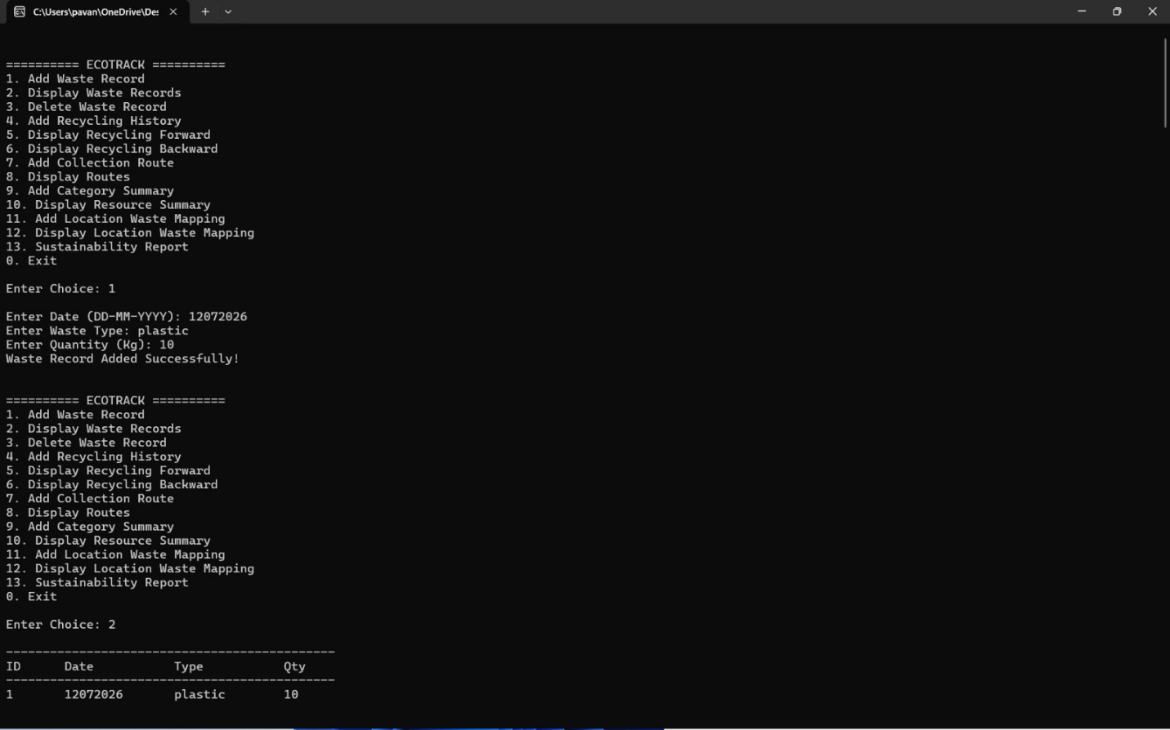
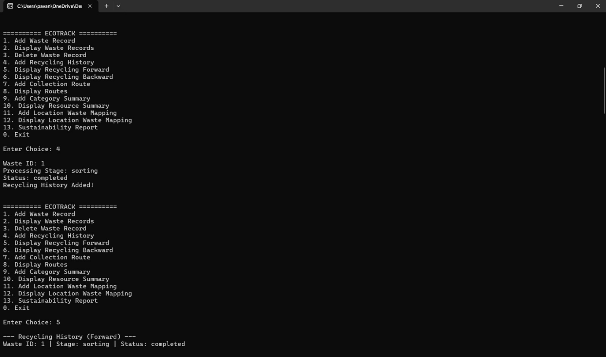
Case 2:
Case 3:
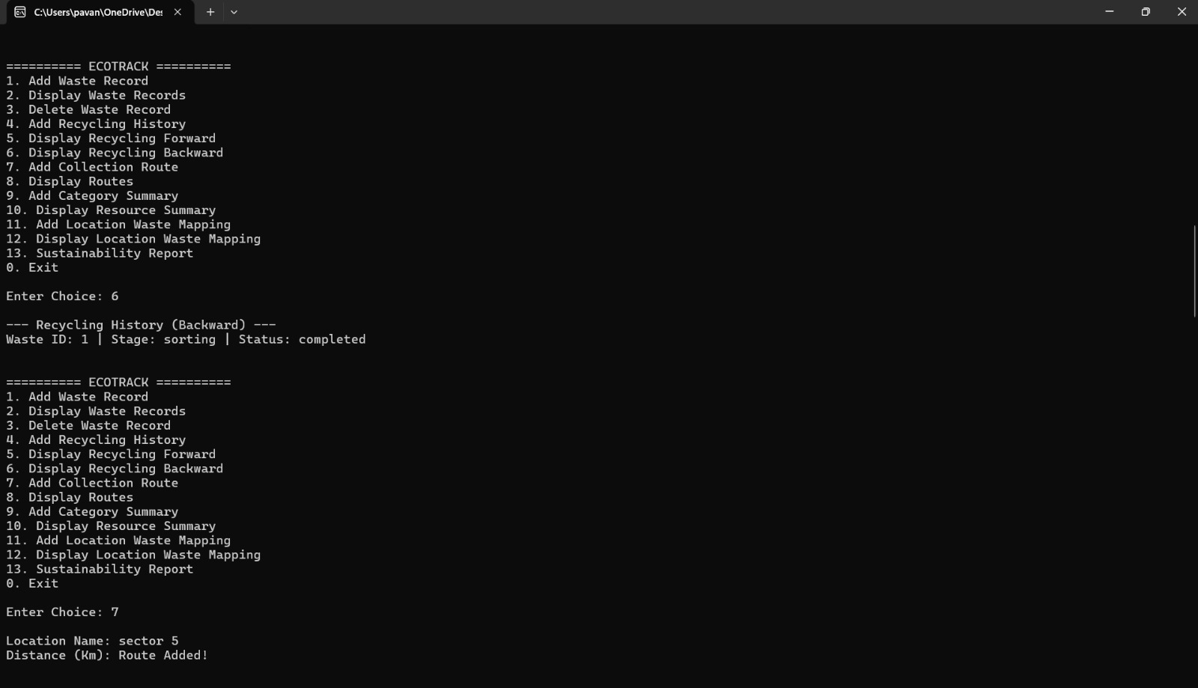
Case 4:
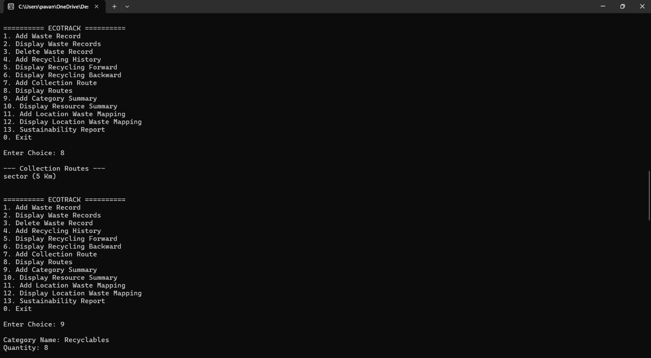

Case 5:
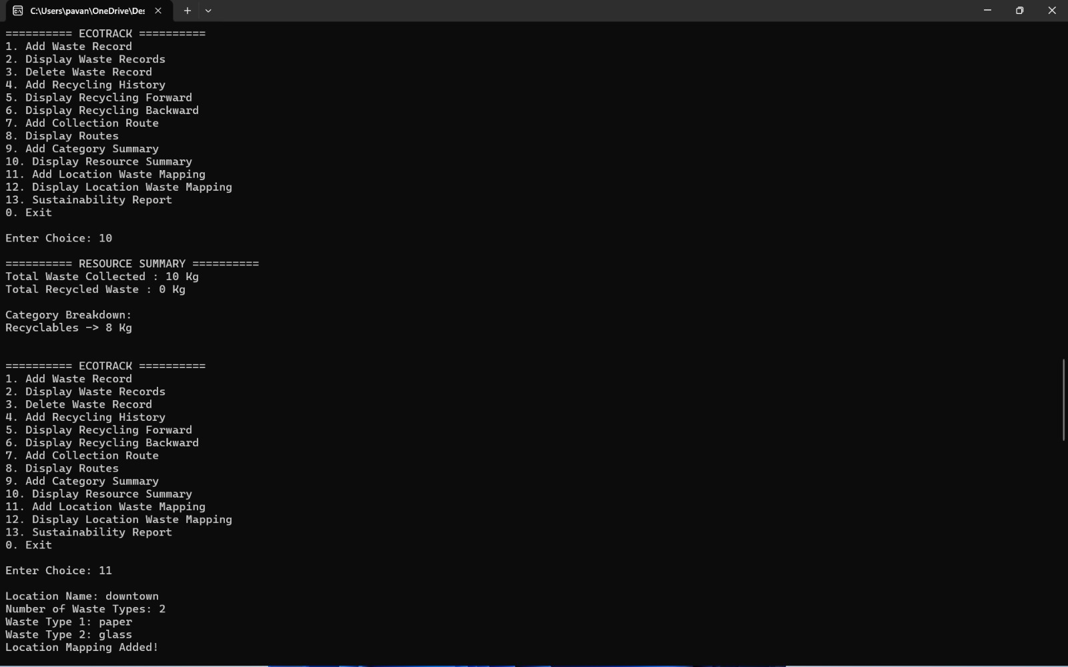
Case 6:
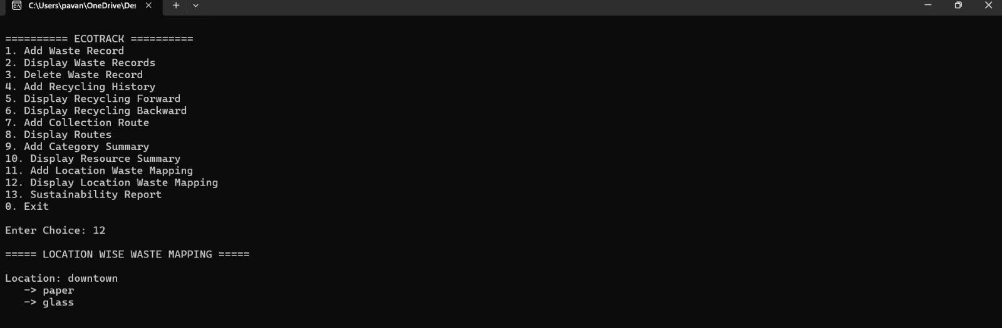
Case 7:
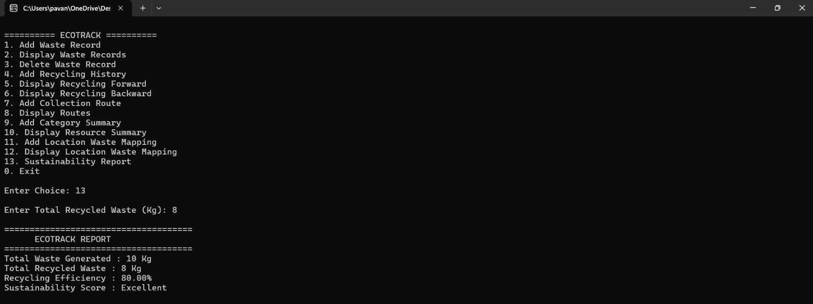

Case 8:
